- Go the following URL to access the login page. (Be sure to place this URL in the Address Bar, not a search engine.):
https://login.healthstream.com/hstmsts/login.aspx?ReturnUrl=%2fHSTMSTS%2fusers%2fissue.aspx%3fwa%3dwsignin1.0%26wtrealm%3dhttp%253a%252f%252fwww.healthstream.com%252fhlc%26wctx%3drm%253d0%2526id%253dpassive%2526ru%253d%25252fHLC%25252flogin%25252flogin.aspx%25253forganizationID%25253d57fec56b-063c-df11-91e1-001517135511%252526organizationNodeID%25253d91510d95-5e44-e611-bd37-005056b122ea%26wct%3d2016-08-04T11%253a20%253a37Z%26wreply%3dhttps%253a%252f%252fwww.healthstream.com%252fHLC%252flogin%252flogin.aspx%26sts_OrgId%3d57fec56b-063c-df11-91e1-001517135511%26sts_OrgNodeId%3d91510d95-5e44-e611-bd37-005056b122ea&sts_OrgId=57fec56b-063c-df11-91e1-001517135511&sts_OrgNodeId=91510d95-5e44-e611-bd37-005056b122ea&wtrealm=http%3a%2f%2fwww.healthstream.com%2fhlc&bhcp=0
- Under the green Login button, click “First time students click here to register”:
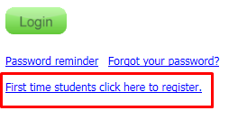

- When creating an account, all required fields are marked with an orange asterisk. Here is a listing of those fields along with some tips:
- Last name
- First name—Use your full name as listed on file with your organization, not a nickname
- User ID – Remember what you enter for your Userid as you will use it for future logins
- Password—Remember what you enter for your Password as you will use it for future logins. Use the Password Reminder field to give you a hint for future logins.
- Email—This should preferably be your work email address but you may use a personal email address if necessary.
- Time Zone
- Preferred Language
- Hire/Re-hire Date—You may either enter your actual hire date or the system will default this to the current date (which is okay)
- Department—Scroll through this list to select the organization/facility where you work
- Job Title—This listing is of Job Categories. Find the Job Category that your position fits under.
- Active Date—Leave this as the current date.

- Once all fields marked with asterisks are complete, click “Submit” at the bottom of the page.

- Once logged in, go to your “To Do” tab.
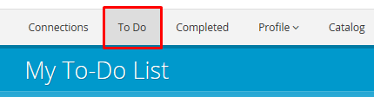
Under your “To Do” tab, you will see courses that have been assigned for you to complete.

- Once you complete your assigned courses, you are able to self-enroll in additional learning if you choose by clicking on the “Catalog tab”:
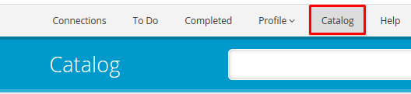
- To view completed courses, click on the “Completed” tab:
